



**SM6P07NI Digital Media Project**

**20% Research and Proposal**

**2021-22 Autumn**

**Student Name: Arbindra Adhikari**

**London Met ID:**

**College ID: NP01MM4S190024**

**External Supervisor: Sandip Lamicchane**

**Internal Supervisor:**

**Assignment Due Date: 28th Dec 2022**

**Assignment Submission Date: 28th Dec 2022**

**Word Count: 1360**

*I confirm that I understand my coursework needs to be submitted online via Google Classroom under the relevant module page before the deadline in order for my assignment to be accepted and marked. I am fully aware that late submissions will be treated as non-submission and a marks of zero will be awarded.*

**Abstract**

This project is mainly about creating a proper documentation where it complies all the necessary elements which are related to TVC Advertisement making and all the necessary aspect by which a successful Musical TVC can be made. This documentation includes all the necessary research done in the field of this project and proposal of the project. This particular documentation can be divided into two parts. talking about the first part of the project it includes all the aspects related to the Client research. It includes the topics like literature review, product review, Client research and many more. This particular section also includes all the elements which are necessary for the proper branding propose. Talking about the second part of this project documentation it talks about the titles like the topic or the title of the project, treatment and also contribution of others. This part also talks about the testing process in which the proper knowledge about this project has been made and initial survey till gives the room for improvement.

Contents

# Section A: Research

For my project I am planning on shooting a TVC commercial which will be a real client-based project, I will be combining all my knowledge on music and video shooting with some 2d if possible, while shooting for the video definitely there will be lots of issues like less people to shoot, small spaces for drone , to solve and overcome them I have asked some help from staffs and the customers.

**2) Client research**

The clients are the folks from the silauto cottage located in annamnagar kathmandu, they have been running the cottage for more than 4-5 years and are kind and really helpful.

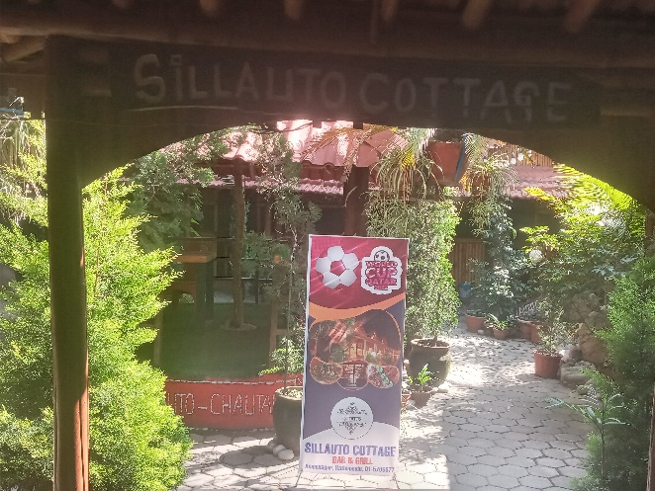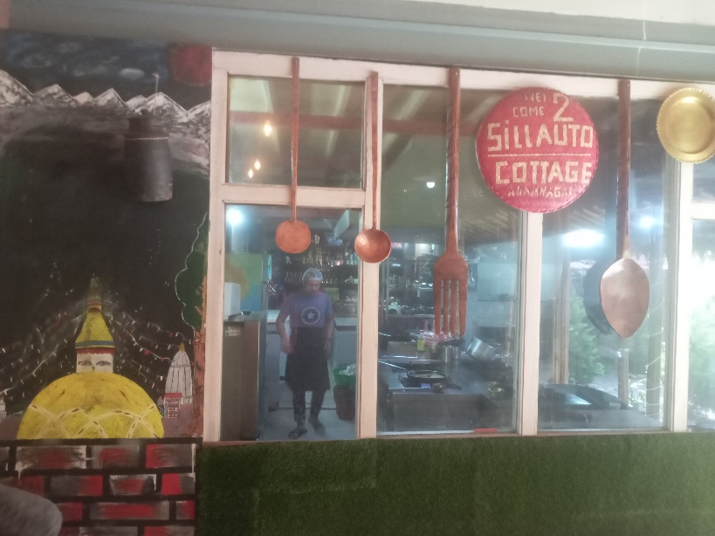

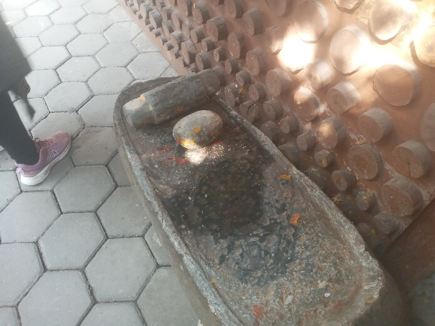

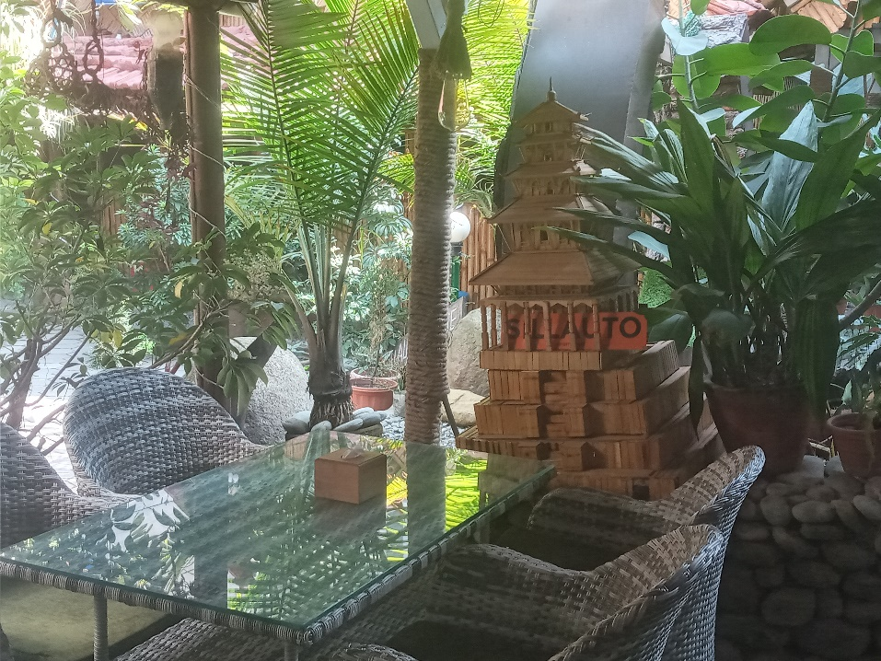

The cottage is having a very good environment and great ambiance as well as great customer services for the audience, not only you can enjoy peaceful sound of the waterfall you can enjoy your delicious foods.

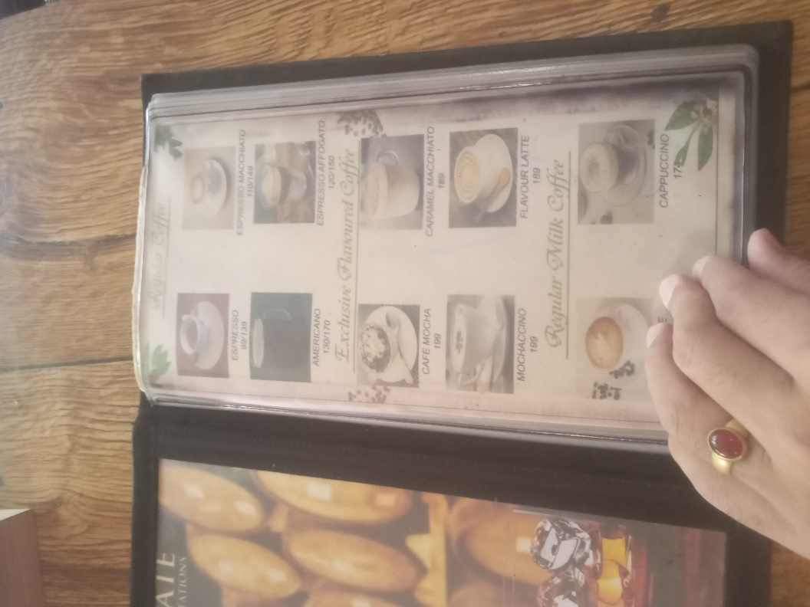

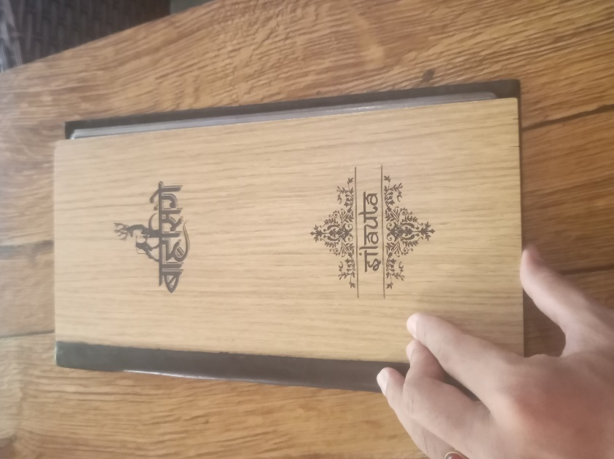

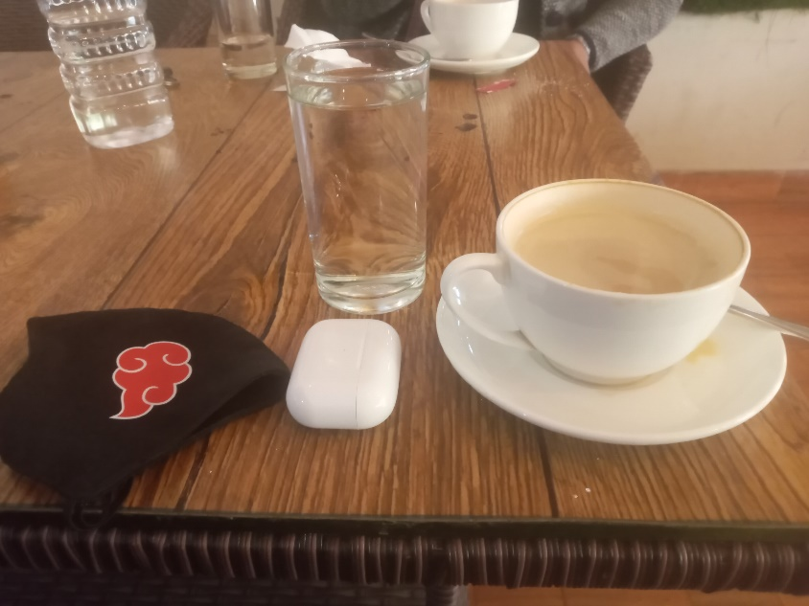

The menu for the cottage bar and grill, you can enjoy all your Nepalis cuisine, morning to dinner worth of foods with the facility of home delivery at any time.



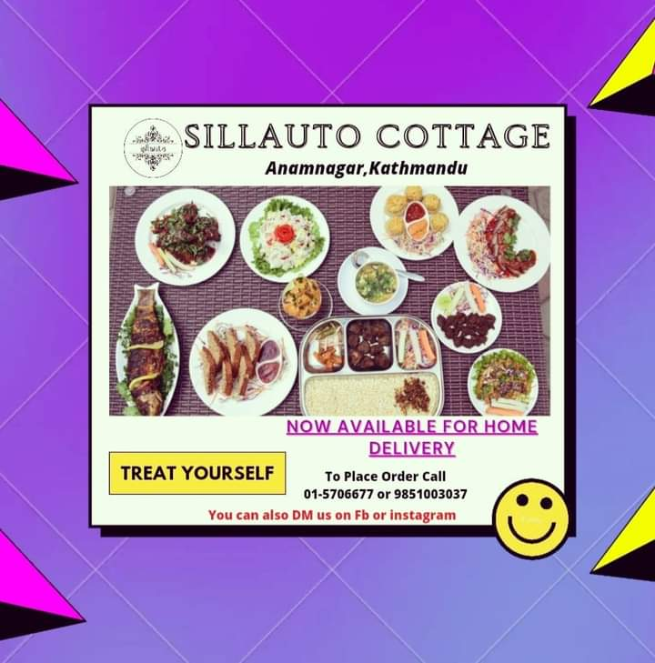

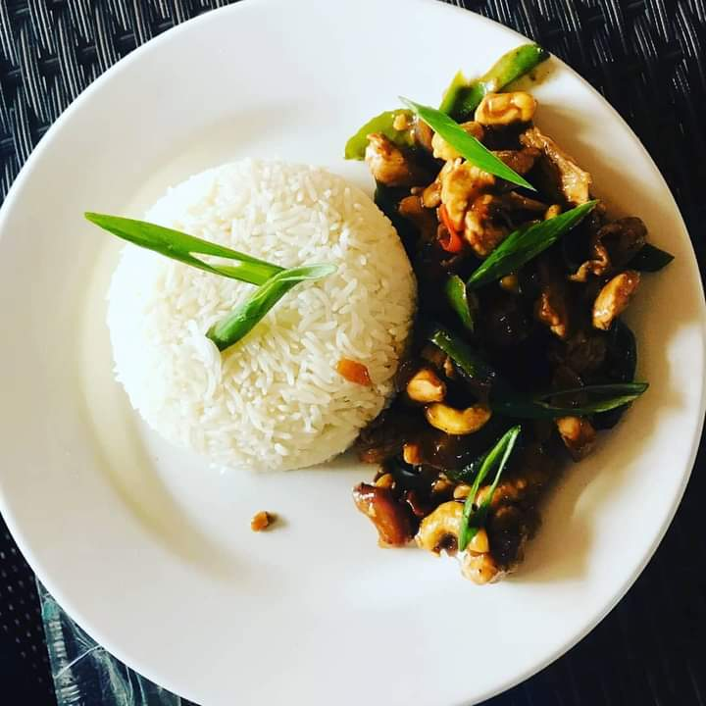

There are many varieties of foods items at the cottage like more of your traditional Nepali food items and typical Nepali cuisine on the board

**Literature Review**



The aim of the project is to create a professional advertisement video, for the client with a proper script and planning to ensure the project success. The project will be a creative and fun as the clients were kind folks

**3) Product Review**

I’m trying to promote the hotel experience through the advertisement and convey a message to the public in a fun way through the means of motion graphics and music.

The project has some inspiration from some emotional food advertisement as well as many hotel/ foods houses advertisement

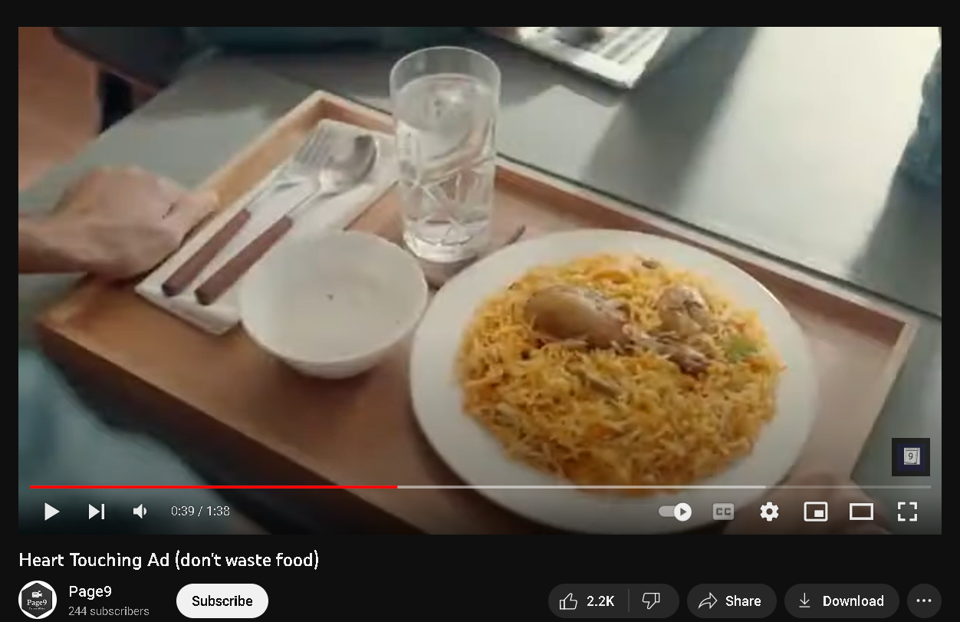

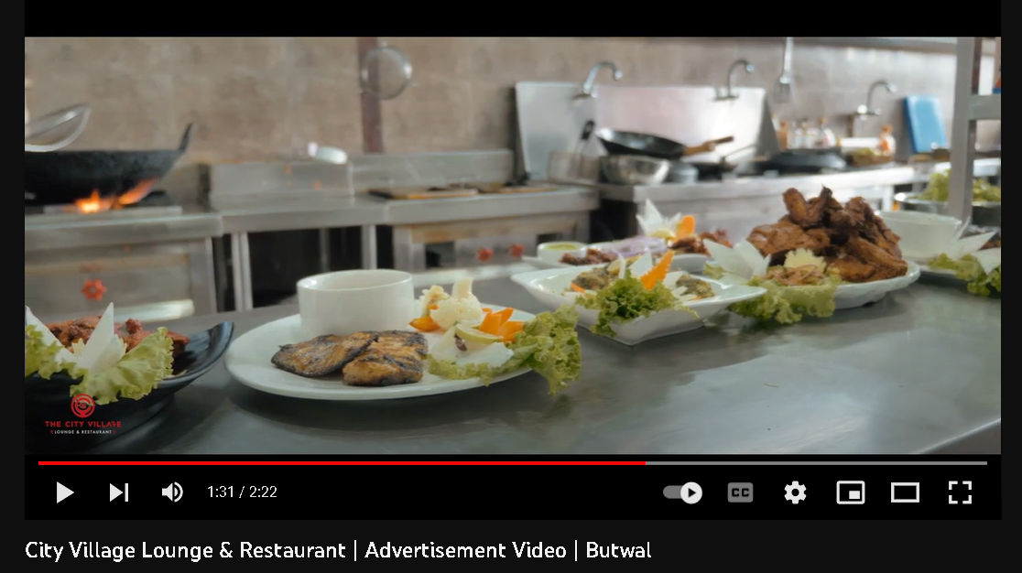

Similarly like in the video I will be showing various food items inside the cottage, the cinematics environment inside the place and the staff working in the kitchen the ambience and customer service will also be shown through the video.

**4) Summary and Conclusions**

This coursework has enlightened me about client-based work film making and camera angle for shooting, which was very helpful and, it has taught me the importance of planning and management of crew, budget, cinematics and, more about, how movies are made. Thank you, sir/Madame,’ for your support and guidance.

Overall, the video should show a proper promotional TVs advertisement which can give a proper message as well as satisfy the viewer and hence attract the people to actually go to the place.s

Section B: Project Proposal

**1) Project Title**

A Sillauto cottage experience

I want to capture the love of food and

**2) Research Question**

* How is the video going to help promote the cottage in anamnagar?
* Can the video capture be unique and catch the heart and many?

**3) Treatment**

🡪 Talking about the perspective of the audience after watching this short movie it is going to be very emotional and very motivating. This film will create a clear concept for the viewers that bad habits and consumption of drug will slowly lead to disaster so that they will never attempt or even try those things. Audience will connect to this movie as they can see the problem faced by the character in the movie and also learn how strongly the character faces the problem and at last dealt with the problem. Audience will also get the idea as the story line is hitting the mind of the audience. The message which the story is trying to give is very necessary to be protected so that all the message is clearly being delivered. The film will always be remembered in the mind of the audience as the emotional connection which is being created with the help of this movie will always help them get the necessary motivation they need to walk in the correct direction in their respective lives.

**4) Resources**

**Software**

Adobe software’s will be used to create motion graphics and editing the footage

Da Vinci for color grading

FL studio/reason will be used to create sounds and beats according to the mood of the scenes in the video

**Objects**

* The following are the resources required to shoot and complete the project.

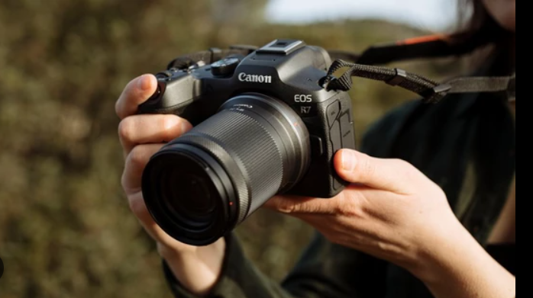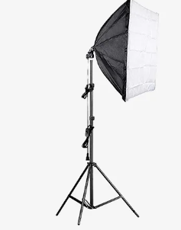

**Cameras**

**Lighting**

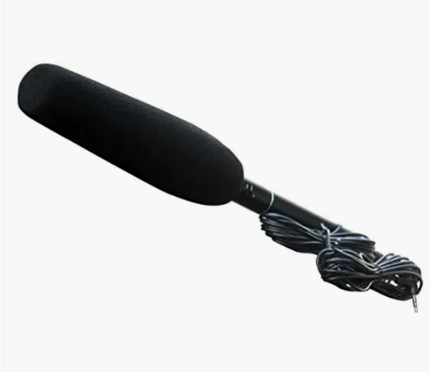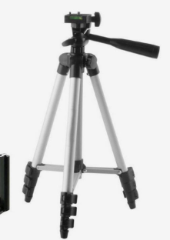

DSLR Microphone

**Tripod**

5 Contribution of Others

The project was only possible because of the people who has worked

6 Evaluation & Testing

I will ask people for their opinion

7) References and Bibliography

<https://www.wikipedia.org/>

video ideas

<https://www.youtube.com/watch?v=qOQtQFh6WFs>

9) Appendix

**Legal and Ethical Considerations**

Before beginning the project, legal and ethical considerations must be made. I was aware of such terms; for copyright difficulties, I would ensure that I have a valid letter before obtaining approvals and authorization. I will only shoot after obtaining permission from the owner to utilize various elements in the video.

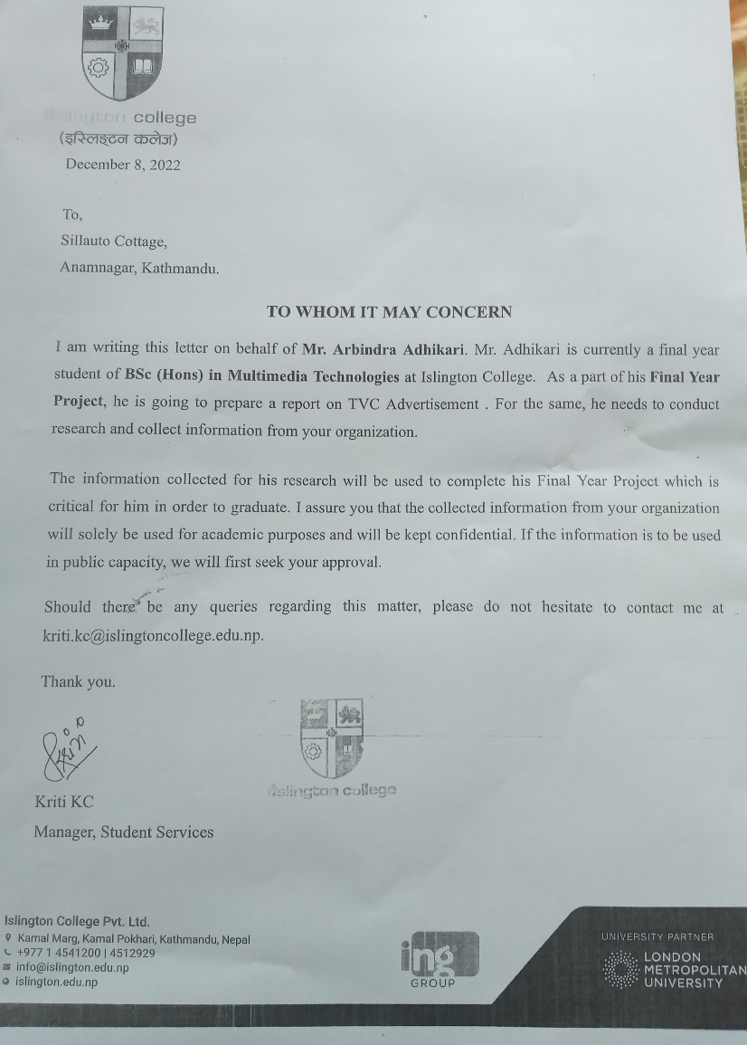

**Gantt chart**

A Gantt chart, which is widely used in project management, is one of the most popular and useful methods of displaying activities (tasks or events) against time. Each activity is represented by a bar, The position and length of the bar reflects the start, duration. and end dates of the activity.

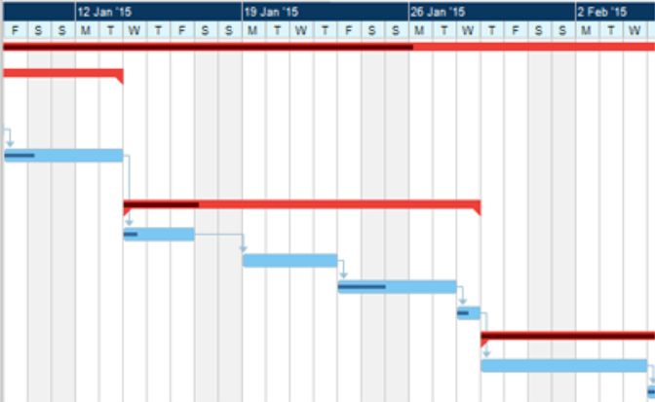

**LOGO AND INTRO**

Starts with showing bunch of hotels and a narration.

(Music piano)

Narration starts

[where ever you go there is nothing closer than your home

But what if your home was ......]

<Video transitions >

{FADE IN}

A person who is really depressed tired from journey and starving while walking in the road is shown in the video

with the (Display of sad vibe/music)

He is in state of exhaustion and about to pass out just then he crashes to the nearby shop and feels the energy and excitement coming inside the vast cottage like it’s calling out to him. (Effect)

(Dramatic silence)

He smells variety of foods and is simply mesmerized by the kindness of the people in the cottage serving him fresh drinks.

(Transition of music to exciting pattern beats)

He sees a small bakery shop but as it turns out its not what the eye meet

(Some great music beats)

He is amazed by the food items and its amazing variety, all the nepali foods and tradition displayed in the small yet amazing cottage gave him chills... (Inspiring beats

The great environment inside the cottage made him feel like his own home

{At last, his mood changes drastically and regained his strength like never before}

**Methodology**:

A methodology for project management is a set of principles and practices that help you organize your projects to get the most out of them.



Roadmap